

**MAULANA AZAD NATIONAL INSTITUTE OF TECHNOLOGY**



technical Report

Yemota Systems & Solutions Pvt. Ltd.

**Designing of a 24 watts led driver**

**using IC ap1682**

Project Guide:-

Prof. Dr. Dheeraj K. Agarwal

1. Akshay Patidar (141114009)

2. Gaurav Thakre (141114045)

3. Satendra Singh (141114022)

**ACKNOWLEDGEMENT**

First and foremost we would like to thank our Institute for giving me the opportunity to pursue winter minor training at **Yemota Systems & Solutions Ptd. Ltd.**

We are highly indebted to **Mr. ARUNRAJ RAJSEKHAR** (Director) & **Mr. REJI K MATHEW** (Technical Director), who shared with us, their ideas and knowledge in a large variety of settings and our mentor **Ms. Divya Yadav & Ms. Priyanka** under whom we have been working in Yemota Systems & Solutions Pvt. Ltd. We are grateful to her ideas, experience and knowledge related to our project and to the useful recommendations and assistance provided to us. The vision, integrity and sense of quality that we learnt from them is truly uncommon. Her way of explaining and clearing concept helped us in increasing our practical approach. We are very much thankful for her wise and synergetic help throughout our training period.

We would like to thank all the members of department for always making us feel as a team with them & helped us in increasing our knowledge & understanding of working in an organization. We are grateful to them for their unending support and for all those good times we shared.

We also express our gratitude to all the other employees of Yemota Systems & Solutions Pvt. Ltd. for making our training at the company a wonderful experience.

In the end we will like to pay our gratitude to **Mr. ARUNRAJ RAJSEKHAR** (Director), Yemota Systems & Solutions Pvt. Ltd., Bhopal for their support.

Gaurav Thakre

Satendra Singh

Akshay Patidar

**CONTENTS:-**

1. Abstract

2. Yemota Systems & Solutions Pvt. Ltd.

* Traffic Signal Division
* Products
* Services
* Resources
* Costumer Products Division
* ENRISE – The Intelligent Solar Inverter

3. Theory

* Principle of operation of flyback converter
* Description of IC AP1682

4. Project

* Designing of a 24 Watt LED Driver using IC AP1682
* Unregulated 230V AC
* Filter circuit
* Bridge Rectifier
* Flyback Converter
* OptoCoupler
* Calculations of a 24 Watt LED Driver using IC AP1682

**ABSTRACT**

Yemota Systems & Solutions PVT. LTD. provides a great platform for the budding engineers to gain a valuable experience and that too in such a helpful and caring culture as well as people.

Although the enormous amount of work done and experience gained in the past half month can’t be just listed in a few lines but here is an overview of the training.

Our training started on 14th December 2016, after general introduction of company. We were sent to Trainee lab, manufacturing room and R&D department. The Trainee lab, in which we were working, is mainly responsible for process improvements and creating the work culture in the company for making the product more efficiently and effectively. We also learnt soldering in the manufacturing room. The main function of the Trainee lab & R&D is to derive new visions and policies/strategies to meet the key performance targets. While the department is working under various projects , We were working in the R&D in the design of a 24 Watt LED Driver using IC AP1682.

We worked and studied on our project and analyzed the functioning of IC AP1682 & FLYBACK Converter. We studied the various issues related to enhance the concept of feedbacks from Primary & Secondary windings. We also recognize various hazards and risks by studying LED Drivers and various measures related to Safety, Health and Environment.

**Yemota Systems & Solutions Pvt. Ltd.**

Yemota Systems & Solutions Pvt. Limited is a company that promises Traffic Solutions & Signals, LED based lightings, Electrical Connectors & Circuits for all by providing quality products to meet the requirements of present day Traffic Signals and committed to care the people for keeping Traffic discipline.

Yemota Systems has won many accolades in the domestic Traffic domain. We are pioneers, engaged in manufacturing, installation, maintenance and successful running of Traffic Signalling Systems in Madhya Pradesh. Our Strength is the after Sales Service and back up provided to the concerned authorities and departments on quick time response basis. Our commitment towards quality, rich industry experience together with ethical business values have taken us a long way in gaining a National recognition. We possess an image of a widely recognized manufacturer and Service Provider of Traffic Systems.

Yemota Systems is amongst the Top 5 Traffic Systems & Solutions Manufacturing companies in India. We are well placed to realize our aspirations of being amongst the top manufacturing companies and attain a good size of the market. As we step into the next phase, we are driven by our ambition, willing to invest in the growth of our people and business, marching towards the new horizon of Traffic Systems & Solutions.

Our Vision is to become an Advanced Systems & Solutions research based manufacturing and installation Company and to emerge out as an intellectually strong player in the National Level. We have formidably grown to an integrated manufacturing company with a strong strategy and unwavering dedication and the will to win of Team Yemota across the miles that we have traversed this journey so far. Our Company is committed to provide the best quality Systems & Solutions.

**Values :**

* Achieving customer satisfaction is fundamental to our business
* Provide products & services of the highest quality
* Manage our operations with high concern for safety and environment

**Aspirations:**

* To develop indigenous technologies for manufacturing of new Systems
* To have an excellent Human Resources for creating in house intellectual platform

**Traffic Signals Division**

**PRODUCTS -**

* [Controllers](http://www.yemotasystems.com/traffic/products/78-controllers)
* [LED Traffic Signal Aspects](http://www.yemotasystems.com/traffic/products/19-led-traffic-signal-aspects)
* [Count Down Timers](http://www.yemotasystems.com/traffic/products/79-count-down-timers)
* [LED Lights](http://www.yemotasystems.com/traffic/products/80-led-lights)
* [LED Moving Message Display](http://www.yemotasystems.com/traffic/products/81-led-moving-message-display)
* [Solar Traffic Products](http://www.yemotasystems.com/traffic/products/82-solar-traffic-products)

## SERVICES -

## Yemota offers consultancy in Traffic Systems Management:

### Traffic Operation Analysis

The gamut of activities covers the analysis for Traffic volume ratio at intersections, stopped delay and total delay at intersections, average travel speed , Micro and macro level traffic engineering studies Collection of data on traffic flow, speed, density, delay, spacing etc. Feasibility study for installation of fixed time traffic signals, to assess the traffic flow characteristics. The requirement of control systems. Directional traffic volume, existing phase patterns, saturation flow, travel speed, length between intersections etc .Traffic circulation plans Public transport and pedestrian facilities Studies for bus lanes, Pedestrian volume studies, school crossing studies etc. are conducted.

### Traffic Signal Maintenance

Traffic control systems maintenance of world class standards are offered by YEMOTA. This is done through a well-trained maintenance team ably supported by spares in tandem with state of the art technology. Yemota has a Mobile maintenance unit to attend the faults in minimum time. Generally these activities include maintenance services , periodic cleaning, up dating and fine tuning of fixed time signal plans etc.

**Yemota undertake comprehensive maintenance services for traffic signal installations (all make). The scope of maintenance services can include :**

* Surveillance
* Periodic cleaning
* Preventive maintenance
* Updating of timing plans

**RESOURCES** -

Traffic Signal Coordination

## How Traffic Signal Coordination Works

For traffic signals along a street to remain synchronized, they must have the same cycle length, which is the time it takes a signal to go from green to yellow to red and then back to green. Cycle lengths typically range from one to two minutes. In order to minimize stops, signals are coordinated to provide progression for vehicles, which means the light turns green prior to their approach. Progression is determined by the “offset” of the green light, or the time it takes to travel between intersections.

Imagine that each traffic signal has a clock with a second hand. Each signal’s second hand is staggered from the others to allow travel time for each direction. Perfect progression is possible on one-way streets. The quality of progression along two-way streets in both directions is dependent on many factors, including: consistent signal spacing (ideally 1/2 mile apart), side street traffic volume and accommodating pedestrians, left turns and transit.

### Yemota’s Red light monitoring system

With growth in traffic, there is occurrence of bundle of problems too; these problems include traffic jams, accidents and traffic rule violation at the heavy traffic signals. This in turn has an adverse effect on the economy of the country as well as the loss of lives. The expected increase of cars, two wheelers other vehicles expected to increase So problem given above will become worst in the future. Today red light violation is one of the most common and serious problem which results of millions of vehicles at the traffic light signals every year. A red light violation occurs when a vehicle try to cross the intersection at the red traffic light. So to give the punishment to the drivers of these vehicles, we must identify the vehicle that violates the traffic light signals.

**CONSUMER PRODUCTS DIVISION**

**Mission:**

YSSL mission is to attain total customer satisfaction through quality products, timely delivery and prompt after sales service and make solar energy products available to every house hold at an affordable cost.

ENRISE Solar Energy is customised to meet the requirements of each Indian House, making it part of your home.

Yemota launches the Intelligent Home Series Energy Plant, with a unique technology – Intelligent dual grid energy control system, which is known as ‘i - Grid’. Installing enrise solar energy products is like starting your own Power Plants to generate your own electricity for Home/Residential Premises/Parks/Office/Business Counters, thereby reduce the dependency on state generated electricity.

* Enrise Solar Energy offers uninterrupted power supply
* Enrise Solar Energy optimizes the utilization of grid power
* Enrise Solar Energy stabilizes the output voltage & protects your consumer durables from High voltage
* Enrise Solar Energy, which has the ‘i - Grid’ inbuilt, will access the solar charging and do the dual shift from on grid to off grid for power saving
* Enrise Solar Energy, which has the ‘i - Grid’ inbuilt, will ensure power utilization of solar energy as per daily production
* Enrise Solar Energy, which has the ‘i - Grid’ inbuilt, will function as 4- in-1. As a Solar Energy Plant, Energy Saver, Stabilizer & Inverter
* Enrise Solar Energy, which has the ‘i - Grid’ inbuilt, an ON & OFF GRID SOLAR ENERGY PLANT

**2**

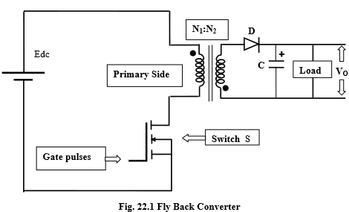FLYBACK CONVERTER

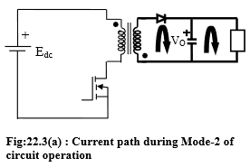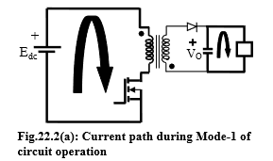

**PRINCIPLE OF OPERATION**

During its operation fly-back converter assumes different circuit-configurations. Each of these circuit configurations have been referred here as modes of circuit operation. The complete operation of the power supply circuit is explained with the help of functionally equivalent circuits in these different modes.

When switch ‘S’ is on, the primary winding of the transformer gets connected to the input supply with its dotted end connected to the positive side. At this time the diode ‘D’ connected in series with the secondary winding gets reverse biased due to the induced voltage in the secondary (dotted end potential being higher). Thus with the turning on of switch ‘S’, primary winding is able to carry current but current in the secondary winding is blocked due to the reverse biased diode. The flux established in the transformer core and linking the windings is entirely due to the primary winding current. This mode of circuit has been described here as Mode-1 of circuit operation. Fig. 22.2(a) shows (in bold line) the current carrying part of the circuit and Fig. 22.2(b) shows the circuit that is functionally equivalent to the fly-back circuit during mode-1. In the equivalent circuit shown, the conducting switch or diode is taken as a shorted switch and the device that is not conducting is taken as an open switch. This representation of switch is in line with our assumption where the switches and diodes are assumed to have ideal nature, having zero voltage drop during conduction and zero leakage current during off state.

Under Mode-1, the input supply voltage appears across the primary winding inductance and the primary current rises linearly. The following mathematical relation gives an expression for current rise through the primary winding:

Linear rise of primary winding current during mode-1 is shown in Fig.22.5(a) and Fig.22.5(b). As described later, the fly-back circuit may have continuous flux operation or discontinuous flux operation. The waveforms in Fig.22.5(a) and Fig.22.5(b) correspond to circuit operations in continuous and discontinuous flux respectively. In case the circuit works in continuous flux mode, the magnetic flux in the transformer core is not reset to zero before the next cyclic turning ON of switch ‘S’. Since some flux is already present before ‘S’ is turned on, the primary winding

Current in Fig. 22.3(a) abruptly rises to a finite value as the switch is turned on. Magnitude of the current-step corresponds to the primary winding current required to maintain the previous flux in the core.

At the end of switch-conduction (i.e., end of Mode-1), the energy stored in the magnetic field of the fly back inductor-transformer is equal to 2 Pr 2 iP LI , where denotes the magnitude of primary current at the end of conduction period. Even though the secondary winding does not conduct during this mode, the load connected to the output capacitor gets uninterrupted current due to the previously stored charge on the capacitor. During mode-1, assuming a large capacitor, the secondary winding voltage remains almost constant and equals to . During mode-1, dotted end of secondary winding remains at higher potential than the other end. Under this condition, voltage stress across the diode connected to secondary winding (which is now reverse biased) is the sum of the induced voltage in secondary and the output voltage Mode-2 of circuit operation starts when switch ‘S’ is turned off after conducting for some time. The primary winding current path is broken and according to laws of magnetic induction, the voltage polarities across the windings reverse. Reversal of voltage polarities makes the diode in the secondary circuit forward biased. Fig. 22.3(a) shows the current path (in bold line) during mode-2 of circuit operation while Fig. 22.3(b) shows the functional equivalent of the circuit during this mode.

In mode-2, though primary winding current is interrupted due to turning off of the switch ‘S’, the secondary winding immediately starts conducting such that the net mmf produced by the windings do not change abruptly. (mmf is magneto motive force that is responsible for flux production in the core. Mmf, in this case, is the algebraic sum of the ampere-turns of the two windings. Current entering the dotted ends of the windings may be assumed to produce positive mmf and accordingly current entering the opposite end will produce negative mmf.) Continuity of mmf, in magnitude and direction, is automatically ensured as sudden change in mmf is not supported by a practical circuit for reasons mmf is proportional to the flux produced and flux, in turn, decides the energy stored in the magnetic field (energy per unit volume being equal to 2 2 B μ , B being flux per unit area and μ is the permeability of the medium). Sudden change in flux will mean sudden change in the magnetic field energy and this in turn will mean infinite magnitude of instantaneous power, some thing that a practical system cannot support.]

For the idealized circuit considered here, the secondary winding current abruptly rises from zero to 12 P INN as soon as the switch ‘S’ turns off. and denote the number of turns in the primary and secondary windings respectively. The sudden rise of secondary winding current is shown in Fig. 22.5(a) and Fig. 22.5(b). The diode connected in the secondary circuit, as shown in Fig.22.1, allows only the current that enters through the dotted end. It can be seen that the magnitude and current direction in the secondary winding is such that the mmf produced by the two windings does not have any abrupt change. The secondary winding current charges the output capacitor. The + marked end of the capacitor will have positive voltage. The output capacitor is usually sufficiently large such that its voltage doesn’t change appreciably in a single switching cycle but over a period of several cycles the capacitor voltage builds up to its steady state value.

The steady-state magnitude of output capacitor voltage depends on various factors, like, input dc supply, fly-back transformer parameters, switching frequency, switch duty ratio and the load at the output. Capacitor voltage magnitude will stabilize if during each switching cycle, the energy output by the secondary winding equals the energy delivered to the load.

As can be seen from the steady state waveforms of Figs.22.5(a) and 22.5(b), the secondary winding current decays linearly as it flows against the constant output voltage (VO). Under steady-state and under the assumption of zero on-state voltage drop across diode, the secondary winding voltage during this mode equals VO and the primary winding voltage = VON1/N2 (dotted ends of both windings being at lower potential). Under this condition, voltage stress across switch ‘S’ is the sum total of the induced emf in the primary winding and the dc supply voltage

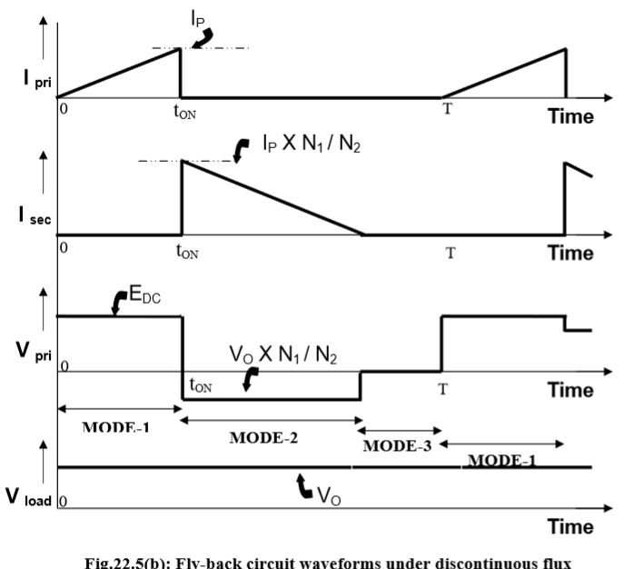The secondary winding, while charging the output capacitor (and feeding the load), starts transferring energy from the magnetic field of the fly back transformer to the power supply output in electrical form. If the off period of the switch is kept large, the secondary current gets sufficient time to decay to zero and magnetic field energy is completely transferred to the output capacitor and load. Flux linked by the windings remain zero until the next turn-on of the switch, and the circuit is under discontinuous flux mode of operation. Alternately, if the off period of the switch is small, the next turn on takes place before the secondary current decays to zero. The circuit is then under continuous flux mode of operation.

**AP1682**

* The AP1682 is a high performance AC/DC universal input Primary Side Regulation Controller with Power Factor Correction for LED driver applications.
* The device uses Pulse Frequency Modulation (PFM) technology to regulate output current while achieving high power factor and low THD.
* Some of the product features include:-
  + Open-load and Reload Detection
  + Over Voltage and Short Circuit Protection
  + Over Temperature Protection
  + Over Current Protection
  + Cost Effective Total PFC LED Driver Solution

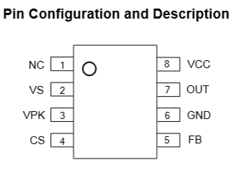

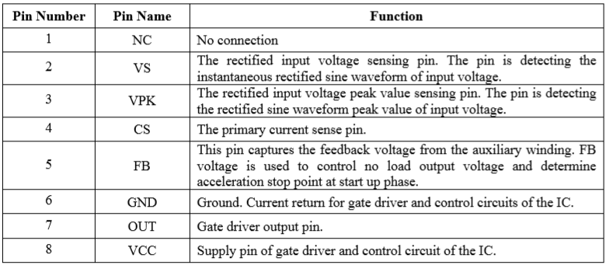

* Typical values required for operation:
  + Vcc=> 18V - Startup threshold.

8V - UVLO voltage threshold.

* + FB=> 3.2V at no load condition.

if >3.2V IC stops firing.

* + OUT=> gives the PFM signal.
  + CS=> 1V
  + VS/VPK=> 0-1
    - We take VS=VPK= 3V

MOSFET

* To perform the switching we use MOSFET . The PWM signal from the IC performs switching operation by providing voltage to the gate of MOSFET.
* MOSFET selection is done by checking the voltage and current ratings for a MOSFET. A balance between low gate charge and RDS(ON) must be achieved in order to keep the temperature of the MOSFET within specification.

OPTOCOUPLER

* Current from input passes through the IR LED which emits an infra-red light that falls upon the base of the photo-transistor, causing it to switch-ON and conduct .
* 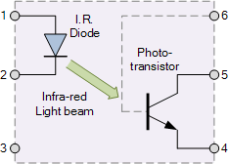The base connection of the photo-transistor can be left open for maximum sensitivity or connected to ground

**3**

**AC to DC converter**

OBJECTIVE :- Design an LED driver to convert 230V, 50 Hz AC mains supply to 12V, 2A 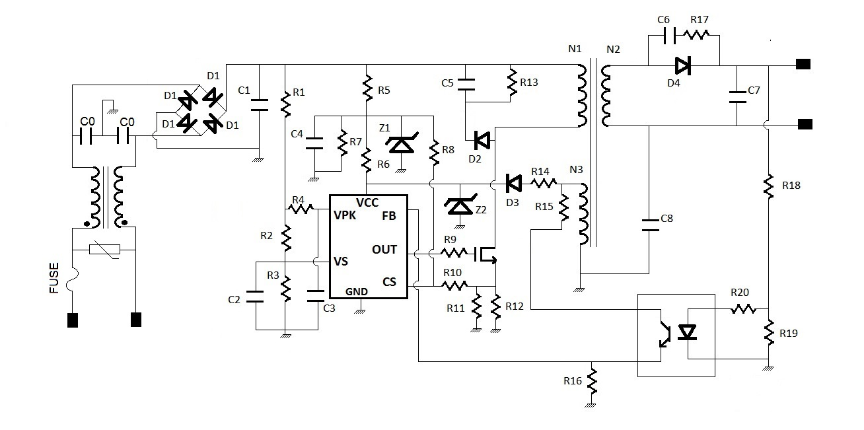

Calculations

* AC mains voltage 230 Vrms
* Nominal DC output voltage: VO=12 V
* Output constant current: IO=2 A
* Assuming,
  + - Full load switching frequency : fSW = 80kHz
    - Transformer efficiency : η = 80%
    - Duty Cycle = 0.46
* Efficiency=Pout/Pin= 0.8
* Pout = (Vo+Vd)*Io
  + where Io=2.05 A, Vo=12 V and Schottky diode forward voltage: Vd = 0.4 V
* Pin =12.4*2.05/0.8 = 31.775 W
* Ip,avg=Pin/Vpri = 31.775/326

Therefore, Ip,avg=97 mA

* Ip,pk=2*Ip,avg/D

=> Ip,pk =424 mA

* Vpri=Lp *di/dt
* Lp=(Vpri*D*Tsw)/ Ip,pk

=>Lp=4.4 mH

Ip*Np=Is*Ns

Is,avg= Ip,avg*Ns/Np

Where Is,avg= 2.05 mA and Ip,avg=Ip,pk*(1-D)*0.5

Therefore 2.05=0.5*(1-0.46)*0.424*Np/Ns

=>Np/Ns =179/10

Also,

(Ls/Lp) = N2 =(Ns/Np)2

Therefore, Ls= 9.5*10-3*Lp

Ls=13.73 uH

* Thus taking turns as:- Np=179 and Ns=10
* Vaux /Naux=(Vo+Vd) /Ns
* Naux=Ns*Vaux/(Vo + Vd) where we want 19 V at auxillary winding
* Naux=10*19V/(12.4) =16

**DESIGN OF FILTER**

**MOV:-** When the transient voltage across the varistor is equal to or greater than the rated value, its resistance suddenly becomes very small turning the varistor into a conductor due to the avalanche effect of its semiconductor material. Thus clipping-off any voltage spikes.

A **line filter** is placed between an electronic equipment and a line external to it, to attenuate conducted radio frequencies, also known as electromagnetic interference (EMI) -- between the line and the equipment.

In this a **choke**/inductor is used to block higher-frequency alternating current (AC) in an electrical circuit, while passing lower-frequency or direct current (DC).

 The choke's impedance increases with frequency. Its low electrical resistance passes both AC and DC with little power loss, but it can limit the amount of AC due to its reactance.

PIV>326-1 (=Vm-Vf )

=> PIV>325

So we choose 1N4005

As its reverse breakdown voltage = 600V

* Input=> 230V(Vrms) , 50 Hz ,AC mains supply
* Output => FULL RECTIFIED WAVE
* Vout=>326V, 100Hz

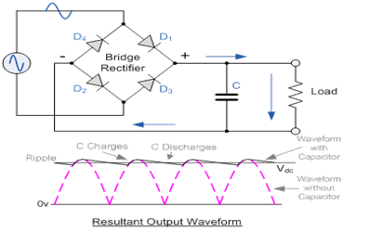

* Taking choke coil of 39 mH , R of the choke coil = 1 ohm

fsw=1/(2*3.14.sqrt(L*2*Cy)

Therefore, Cy= 1/ 4*3.142*fsw2*L*2 where fsw=80 KHz

* + - Cy=50 pF
  + MOV selection
  + Clamping voltage of MOV should be 20% more than the operating peak voltage
  + =>1.2*230*sqrt(2) = 400V
  + MOV used is 07D431K having Vrms=275V
  + FUSE used

Max current= 482mA therefore current rating = 1A

* To convert full rectified wave to unregulated DC.
* The capacitor should be such that the discharge time is very high.
* Therefore, RC>>(1/f) Where Rl=Vin/Iin = 326/(482mA) = 676 ohm
* C >> (1/(80*676*1000))
* => C1 >> 17 uF Therefore take C1=100uF

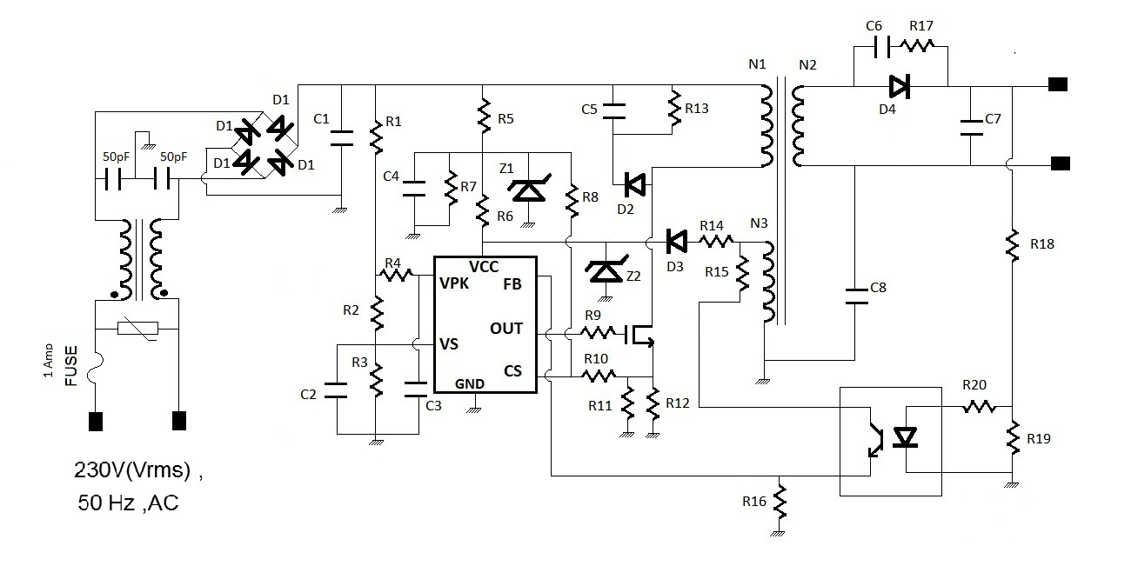

Calculations for VS and VPK pins

* The VPK pin detects the peak average value of the sinusoidal input. This means that when Vin = Vpk,avg=(2*Vrms*sqrt(2))/3.14
* Thus by voltage divider equation we get
* (R2+R3)/(R1+R2+R3) = (3*3.14)/(2*Vrms*sqrt(2)) ­­­­­­­­­­­­­­………………………….eqn (1)
* The VS detects the input sine wave. This means that when Vin reaches its peak value then voltage at point 3V
* Thus by voltage divider we get
* R3/(R1+R2+R3)=3/(Vrms*sqrt(2)) ………………………………………eqn (2)
* Where Vrms = 230 V
* Solving Eqn(1) we get
* (R1+R2+R3)/(R2+R3)=69.2
* and Solving Eqn(2) (R1/R3)+(R2/R3) = (3*3.14)/(2*230*sqrt(2))
* taking R3=1K
* we get R1-68.2*R2 = 68.2
* R1+R2 = 108
* We get R1=106 K ohm R2=570 ohm R3=1K ohm
* FINDING CURRENT:-
* V=IR, P=I2R (230Vrms🡪 325.269V DC)

=>I = 326/(106+ 0.570 +1) => I= 3 mA

* Recommended value of R4 and C3

R4=330K

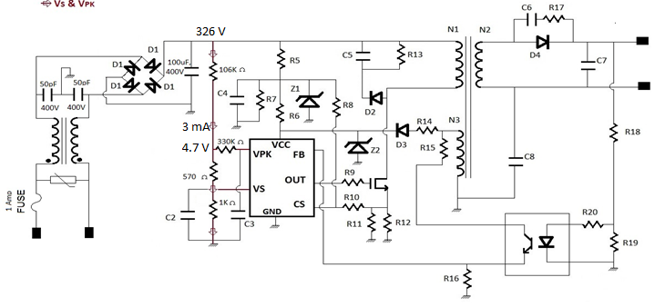 C3=C2=1uF/16V so that corner frequency <10 Hz

Calculations for the Supply (Vcc) circuit

* Zener diode taken

Z1=20V (12.5 mA, 45 mA) : -IN4747, Z2=18V (14 mA, 50 mA) :-IN4746

Maximum zener current that can flow:-

IZ1=45 mA IZ2=50 mA

Applying voltage divider we get

R7*326/(R7+R5) =20 V

R5/R7 =15.3 ………(3)

(20-18)/(5mA) =R6

* R6=400 ohm

Using V=IR , R5= (306/55mA) = 5.6K

* Therefore, from eqn(3) we get R7 = 4K
* Izk=45 mA I=50 uA
* V=IR V=(20-1)V
* =>R8=19/50uA = 380K

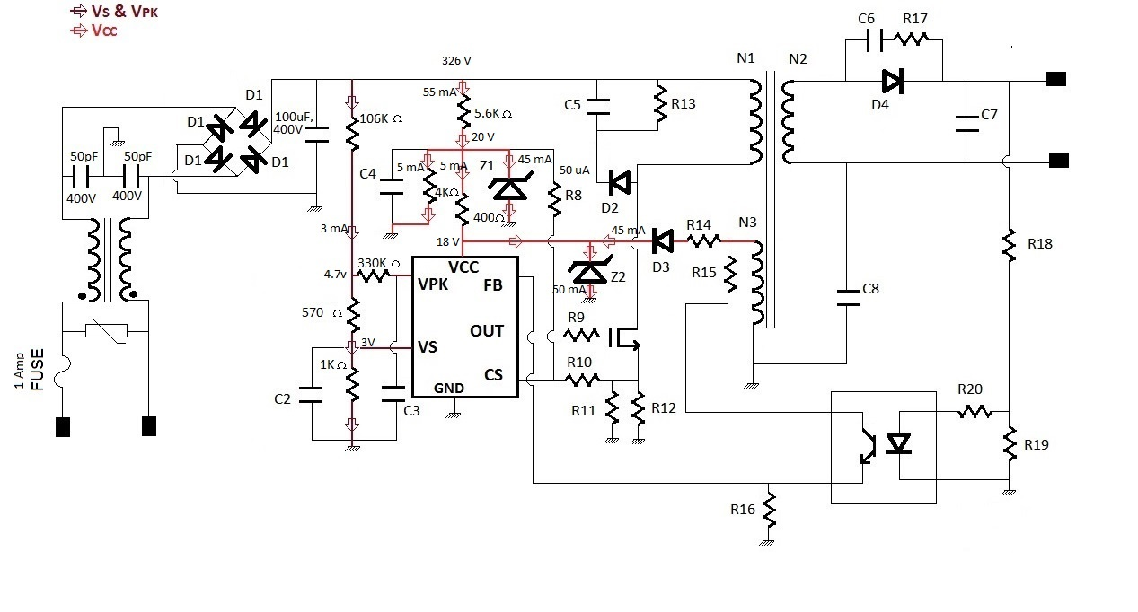

Auxillary supply

* V=IR=> R14=(19-18.4 )/(45 mA)
* =>R14=13.3 ohm

SELECTION OF MOSFET

* Voltage stress across MOSFET
* Voltage stress= sqrt(2)*Vin_rms + Nt*12.4+Vspike

= 755.36 V

* Here, the Vspike is estimated about 100V and Nt (= Np/Ns= 179/10) is the turn ratio. Therefore, a 600V MOSFET device can be used here.
* For MOSFET Rds,on=0.6 ohm

CALCULATIONS FOR CS PIN

* Voltage at CS pin=1V voltage at node below MOSFET =0.9-( Ip,pk*Rds,on )
* Vpri= 326-0.828 ==326V and Ip,pk= 0.424 A
* let R10=1 M ohm
* 0.424 A=0.508/Req => Req=6/5 =1.2 ohm
* 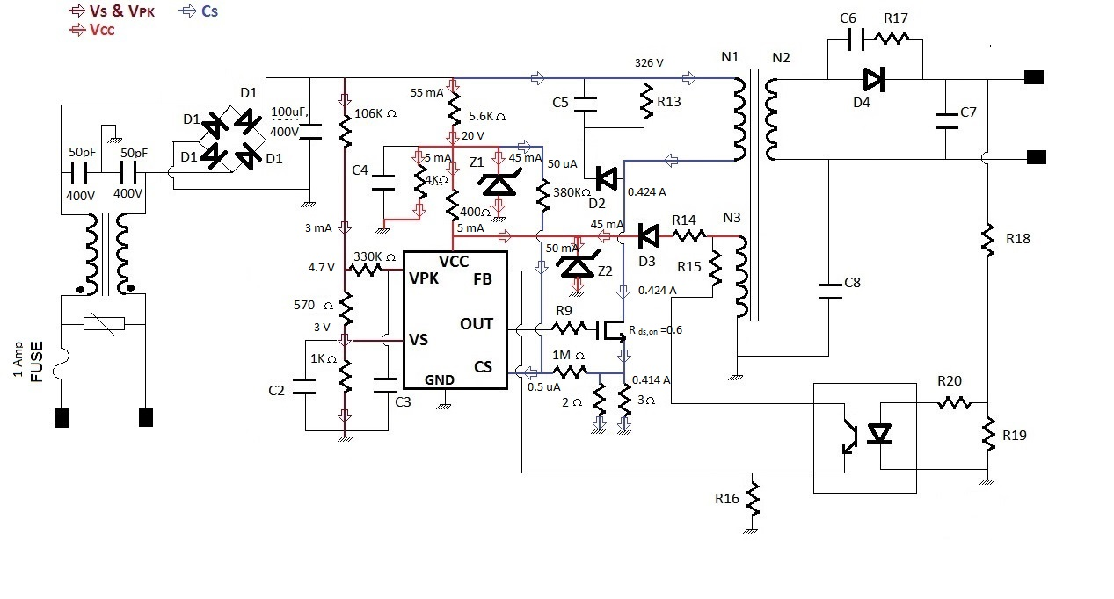R11= 2 ohm and R12=3 ohm

CALCULATIONS FOR SNUBBER CIRCUIT

* Let leakage inductance=10% of Lp
  + =>Lk=0.44 mH
* Energy stored in Leakage inductor=0.5*Lk*I2 =0.5*0.44*0.424*10-3 =39.55 uJ

Power transferred from Lk to snubber circuit = 3.164 W

P=(Vsnubber )2/Rsnubber where Vsnubber =Vin – Vspike =326-100 =226V

Rsnubber =R13= 226*226/3.164 =16 K

* Now, Cs >>Tsw/Rsnubber => Cs >>100/(8*16)Rs
* Cs=C5=1nF, 300V

Snubber circuit for secondary coil

* Vs=Vo+(Vpri*Ns/Np) => 12+326*10/179 => 38.2V
* Power dissipation by the capacitor= 0.5*C*(Vs)2*2*fsw
* Calculating the capacitance by taking the value of power dissipation to be ¼ watt.
* We get ¼ = C*1459.24*80 * 103 => 2 nF
* Therefore C6=2 nF/ 50 V
* Now V= I*R and I = 2.02
* So, R17=(38.2/2.02) = 20 ohm

FB PINCALCULATIONS

* FB pin reference voltage = 3.2 V when Vcc= 18V
* So if the load voltage increases, we want FB pin to detect this rise thus we give it a voltage greater than 3.2V.

(19-18.4)/R =45 mA

R14=15 ohm

* For the optocoupler FODM2701 the conditions are: if If=10 mA then Vce=0.3 V and Ic=2 mA

Therefore, V=IR

R15=(19-4.3)/(2mA) =7.4 K ohm

R16=(4)/(2mA) =2K ohm

* Optocoupler used has If=10 mA (Vf = 1.25V )
* R20=1.8*10/(10mA) =180 ohm
* Using V=IR , R18=10/(50 mA) =200 ohm
* Also, R19= 3/(40mA)= 75 ohm

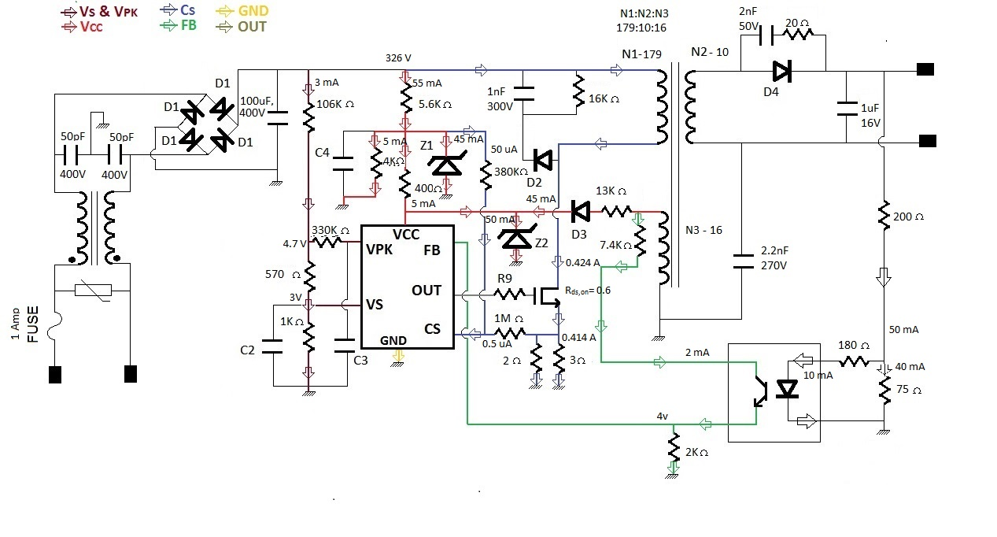

OUTPUT := 12V , 2A

* LED’s are connected as 4 in series then 6 branches in parallel
* Resistance of one LED=9 ohm
* RC>>1/fsw
* Total resistance of combination of LED’s and current limiting resistor

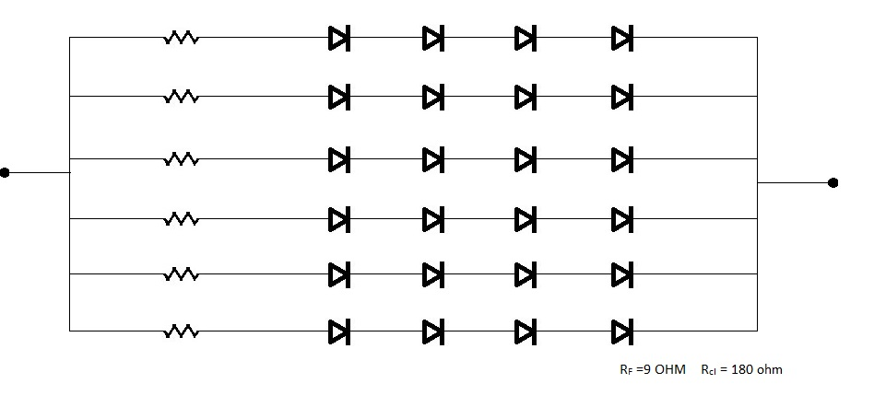(180 ohm)= 36 ohm

* C>>1/(36*80*1000)

=>C7>>0.340 uF

so take C7=1 uF / 16V

C8 = 2.2nf/275V

R9= 20 ohm

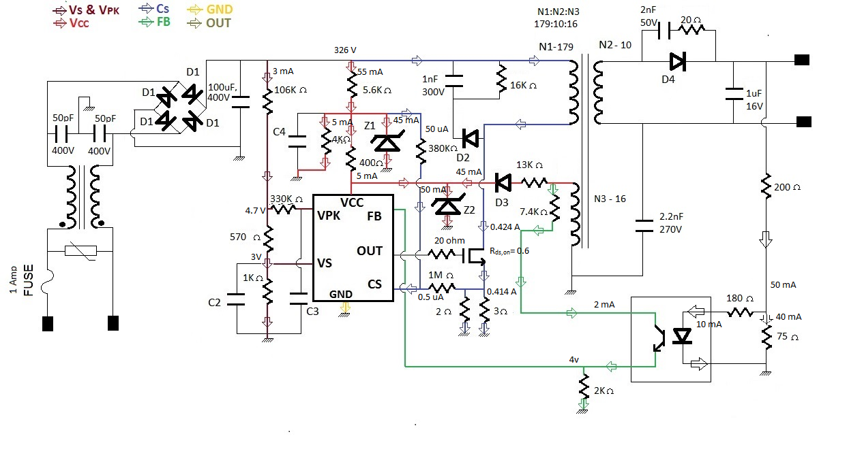Final Circuit